**Setting up Jenkin to do Testing by pulling code from Repo**

**New Item -> Give a Project Name -> Select “Freestyle Project” and then click on “OK”**

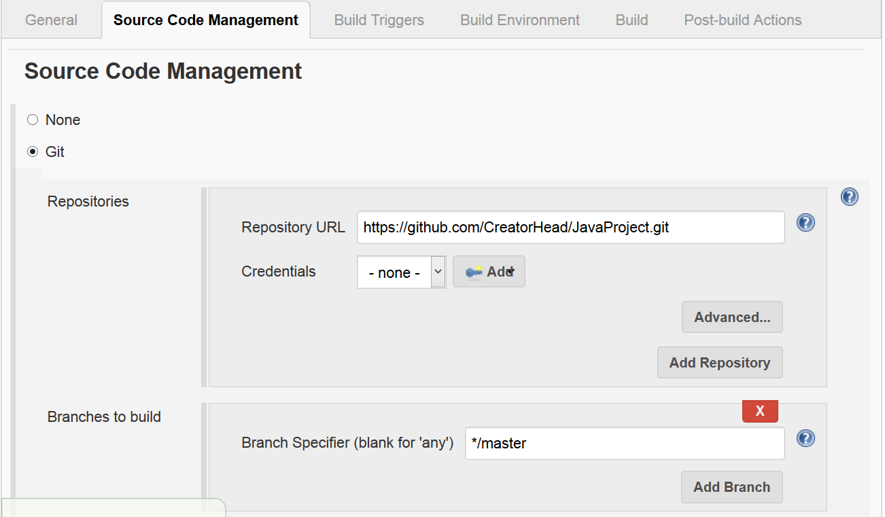

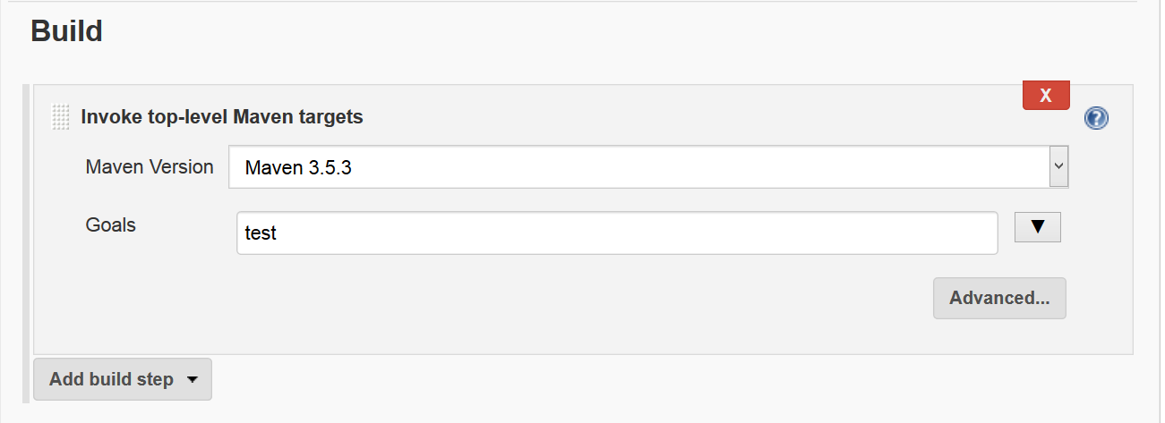

**Click on “Apply” and “Save” and then Click on “Build Now”**